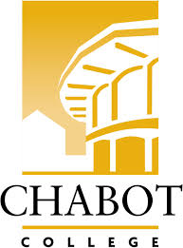
Career Education (CE Committee)
Chabot College – Zoom
Monday, October 7, 2024
12:00-1:00

AGENDA

- Welcome - Terra
  - Introductions
- Information/Discussion Items - Robin
  - Round 9
    - Scenarios
  - Round 8
    - Projects
- Good of the Order - Kristina
- Next Meeting 10/21/2024
- Adjournment

Mission Statement
Chabot College is a dynamic, student-centered community college that serves the educational, career, job skill, and personal development needs of our community. We provide culturally responsive, revitalizing, and sustaining learning and support services driven by a goal of equity. Building upon students’ strengths and voices, we empower students to achieve their goals and lead us towards an equitable and sustainable world.

